KENDRIYA HINDI SANSTHAN, AGRA
(MINISTRY OF EDUCATION,
DEPARTMENT OF HIGHER EDUCATION, LANGUAGE DIVISION)
(Government of India, New Delhi)

(TO BE FILLED IN DUPLICATE & CAPITAL LETTERS)

1. Full Name …………………………………..……………………………………….

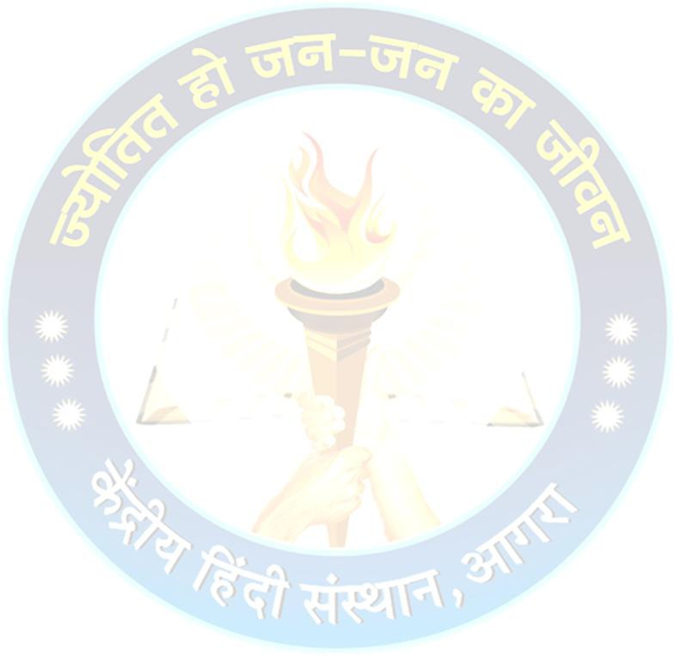
2. Nationality ………………………..….………………………………..........

3. Date of birth (In Christian Era) .……………...……………………………………….......

4. (a) Father’s Name…………………………………………………………………

(b) Mother’s Name …………………………………………………………………………

5. Husband’s/Wife’s name…………………………………………………………………

6. Present Address ……………………………………………………………………....

7. Permanent Address …………………………………………………………………......

8. E-mail ……………………………………..…………………………………..............

9. Phone/Mobile ……………………………………………………………………….....

10. Passport number .....…………………………………………………....
(a) Date of issue of Passport...............................................................................................
(b) Place of issue of Passport.............................................................................................
(c) Validity of Passport ........................................................................................................

11. Occupation …………………………………………………………………………....

12. Previous visits to India, if any ………………………………………………………....
If yes, mention date and place of the visit
…………………………………………………………………………………………….

(Signature of Candidate)

Date : ………………………. Name : …………………………

